CARLINGFORD HIGH SCHOOL

DEPARTMENT OF MATHEMATICS

Year 10 (5.2) Mathematics


Term 4 Yearly Exam 2018

Time allowed : 90 Minutes

Name : ________________________________ Class : 10M2. _____

Please circle your Teacher’s name: Mr Cheng Mrs Pennington
Ms. Strilakos Ms Gamble
Instructions
- Board approved calculators may be used
- Show all necessary working by using blue/ black pen except graphs/diagrams
- Marks may be deducted for untidy setting out

TOPICS | TOTAL
Multiple Choice | / 18
Linear Relationships | / 7
Compound Interest | / 7
Surface Area | / 7
Equations & Inequalities | / 7
Data Analysis | / 7
Graphs | / 7
Trigonometry | / 7
Algebra | / 7
Probability | / 7
Geometry | / 7
Simultaneous Equation | / 7
TOTAL | / 95
Multiple Choice Questions (Suggested time 18 mins, 18 marks)

Questions 1, 2 and 3 refer to this diagram of interval XY

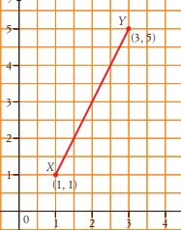

1 | What is the closest length of interval XY ?  (A) 4.5 units (B) 10 units (C) 8 units (D) 3.9 units
2 | What is the midpoint of XY ?  (A) (2, 3) (B) (2.5, 3) (C) ( 2.5, 2.5) (D) (2 , 2.5)
3 | What is the gradient of XY ?  (A) – 3  (B) (C) 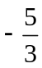 (D) 2
4 | Jane is paid a commission of 2.5% on the value of goods she sells. She also receives a weekly retainer of $875. How much will Jane earn if she sells goods to the value of $41 600 in one week?  (A) $1061.88 (B) $2187.50 (C) $1915 (D) $1018.13
5 | Calculate the area of a semicircle with a diameter of 14 cm.  (A) 21.99 cm² (B) 43.98 cm² (C) 76.97 cm² (D) 153.9 cm²
6 | Which of the following best describes the data displayed in the dot plot below:  (A) Bimodal (B) Positive skewed (C) Normally distributed (D) Negative skewed
   |  |  |  |  | ● |  |  | ●
   |  |  |  |  | ● |  |  | ●
   | ● |  |  | ● | ● | ● |  | ●
   | ● | ● |  | ● | ● | ● |  | ●
   | ● | ● | ● | ● | ● | ● | ● | ● | ●
   | ● | ● | ● | ● | ● | ● | ● | ● | ● | ●
   | ● | ● | ● | ● | ● | ● | ● | ● | ● | ●
   | 2 | 4 | 6 | 8 | 10 | 12 | 14 | 16 | 18 | 20
7 | Solve x² + 3x – 40 = 0.  (A) x = 4 or –10 (B) x = – 4 or 10 (C) x = – 5 or 8 (D) x = 5 or – 8
8 | Theo works as a fitter in a factory and is paid normal rates of $46.50 per hour for a 35 hour week, then time and a half for any overtime.  What would he earn for a week where he worked 42 hours?  (A) $488.25 (B) $1 953.00 (C) $2 115.75 (D) $2 929.50
9 | Solve 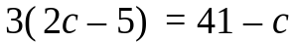  (A) c = 4 (B) c = 5 (C) c = 6 (D) c = 8
10 | 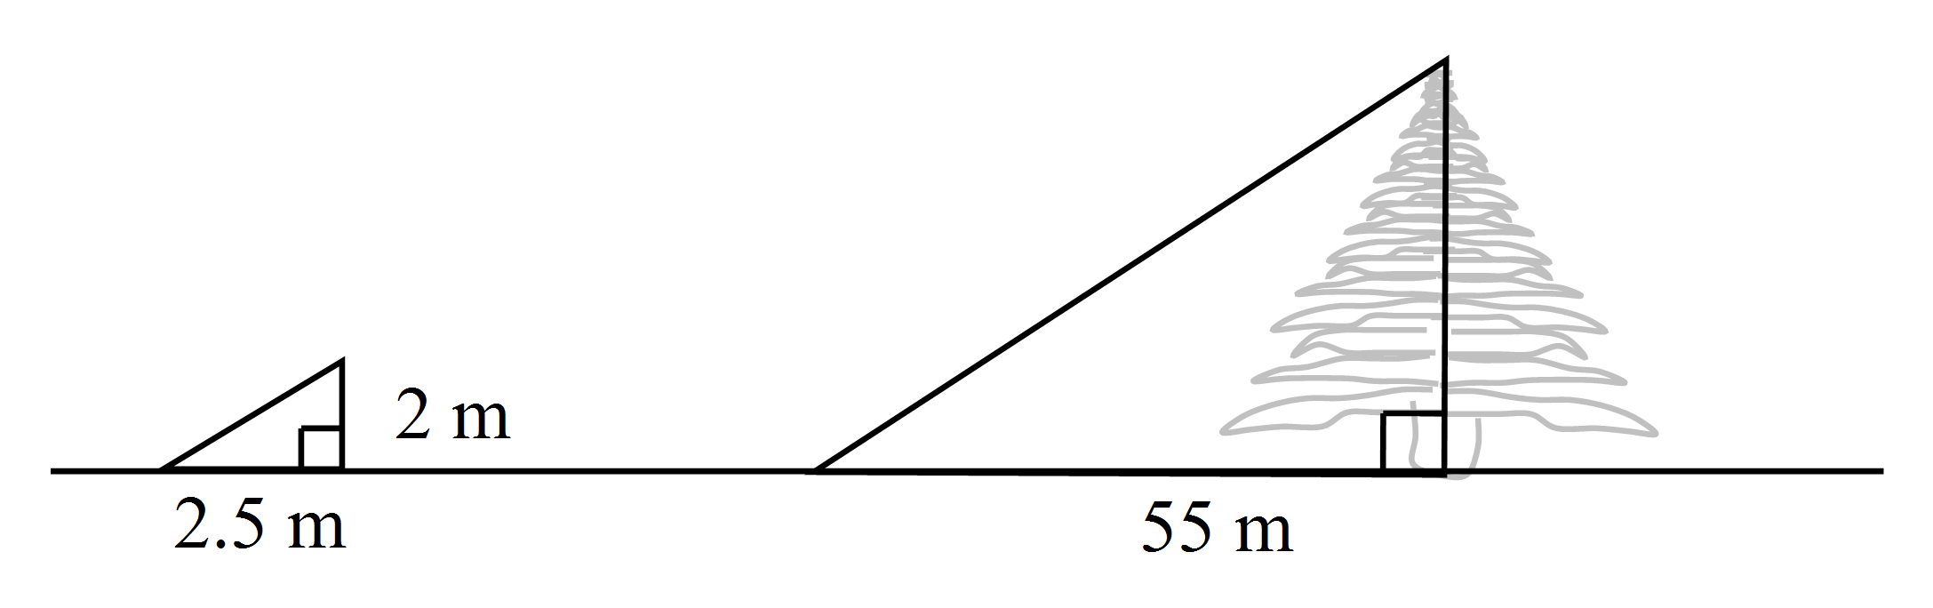To estimate the height of a tree, Tran stands a 2 metre long pole vertically. He measures the length of its shadow to be 2.5 m and the length of the shadow of the tree to be 55 m. The height of the tree is closest to:  (A) 22m (B) 44m (C) 50 m (D) 69m
11 | Which of the following graphs best represents the equation 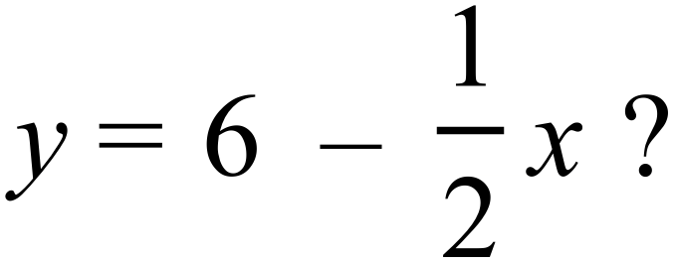  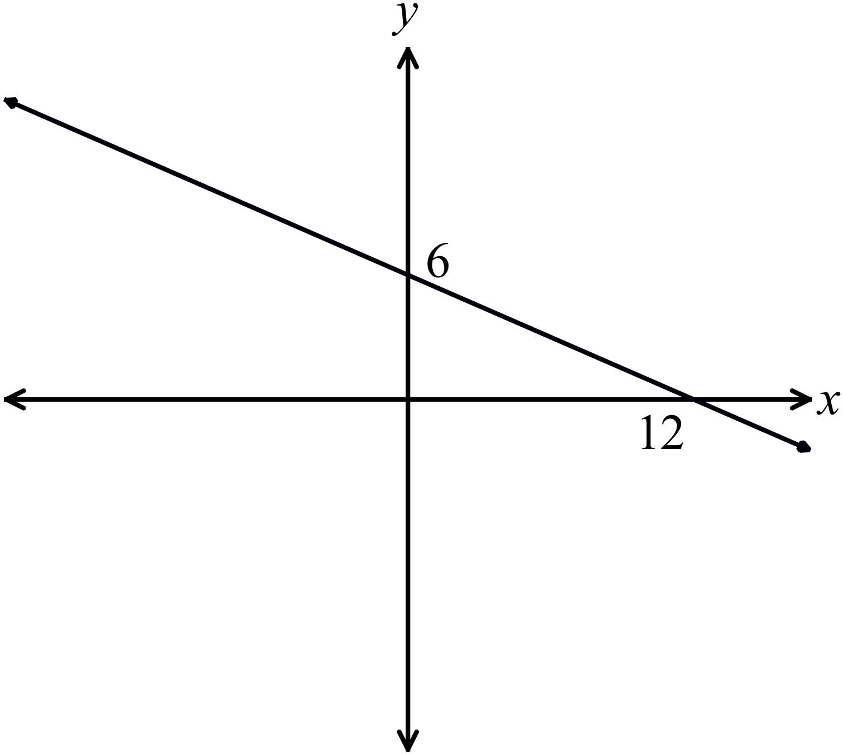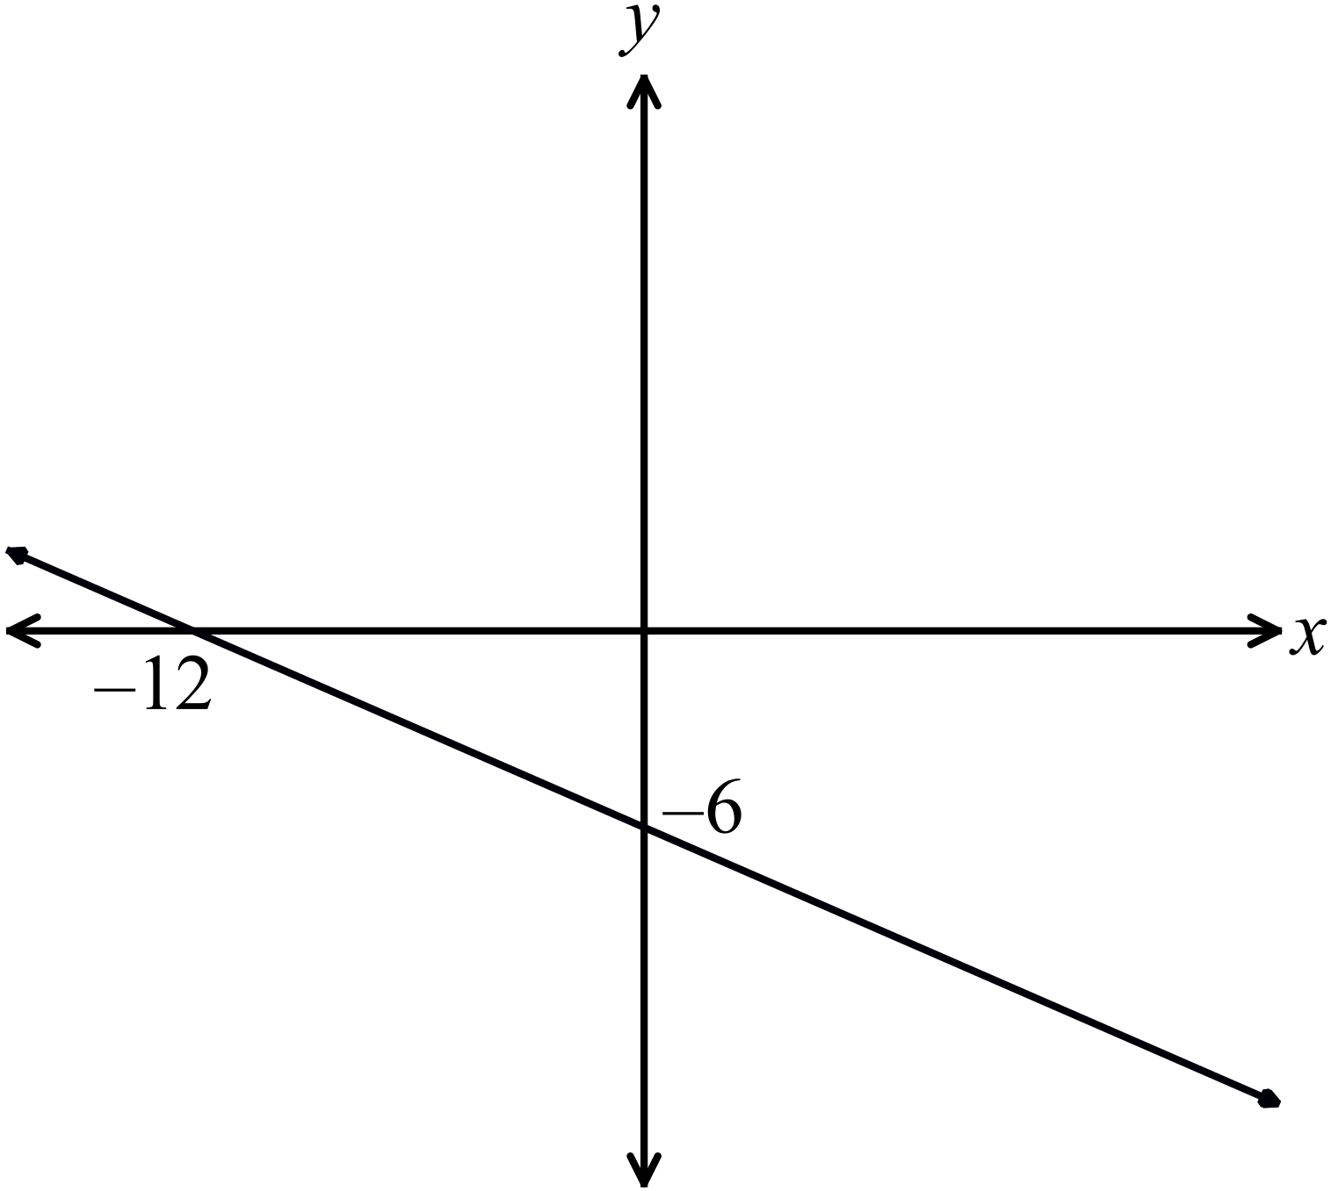(A) (B)  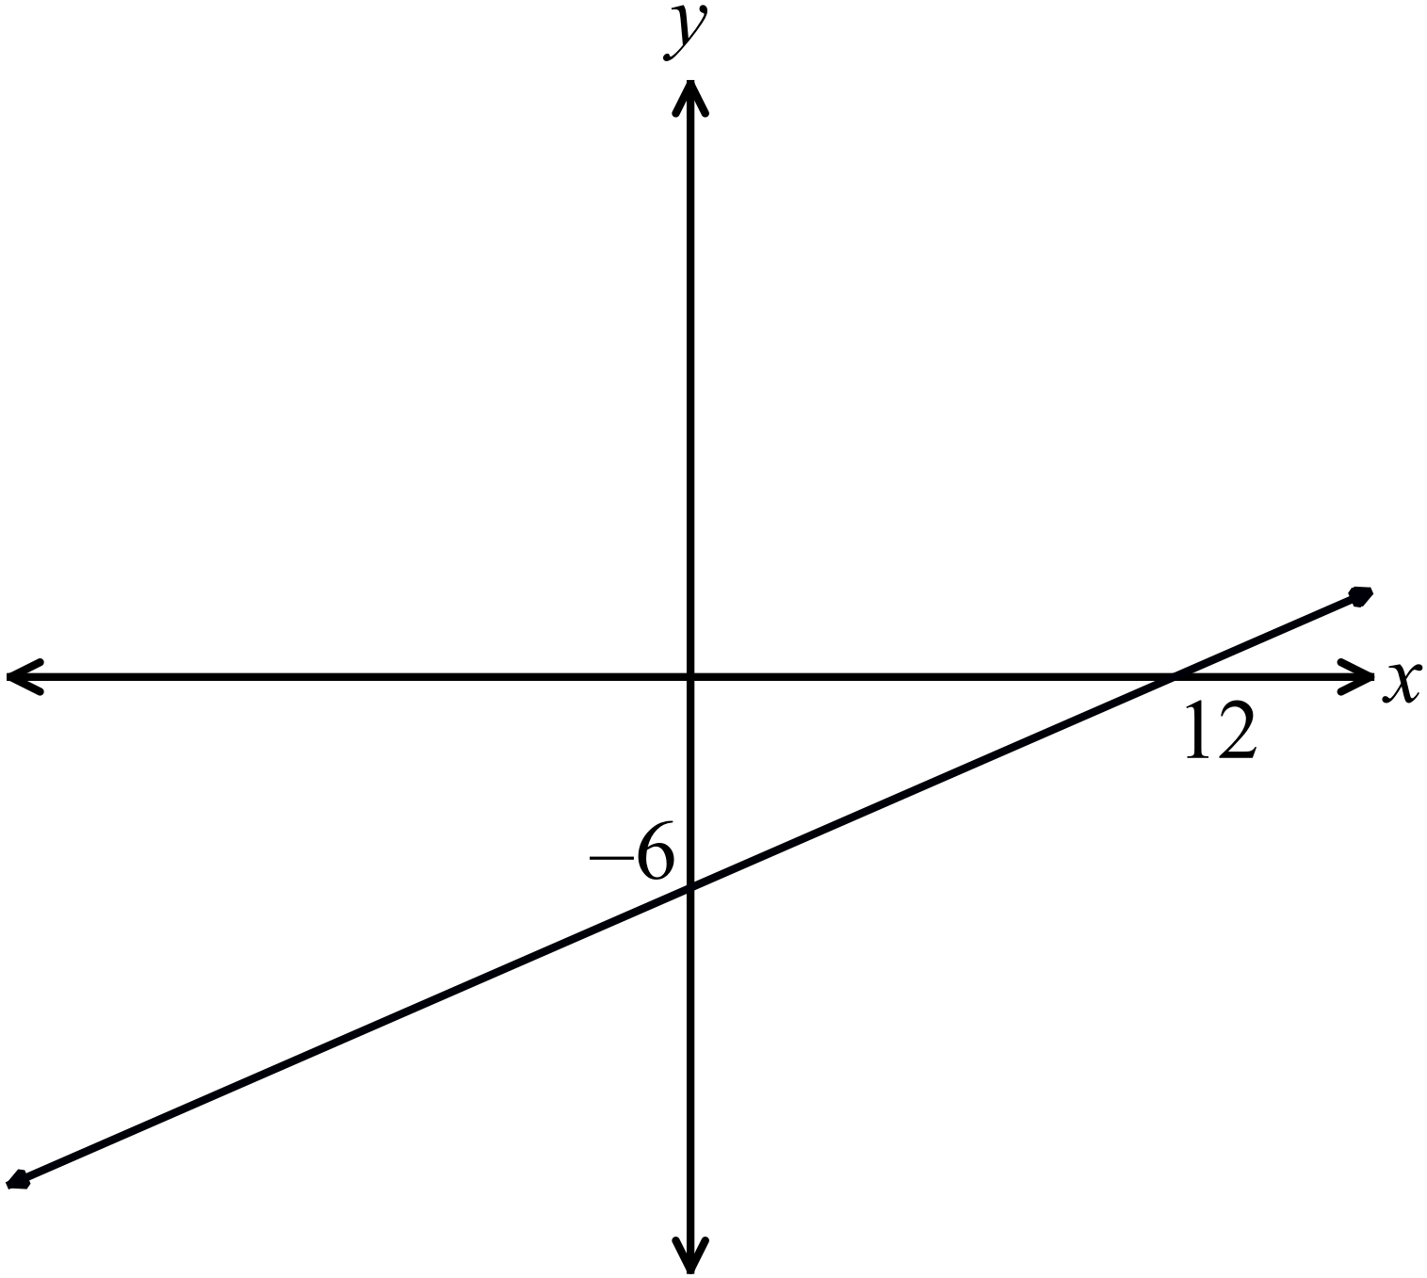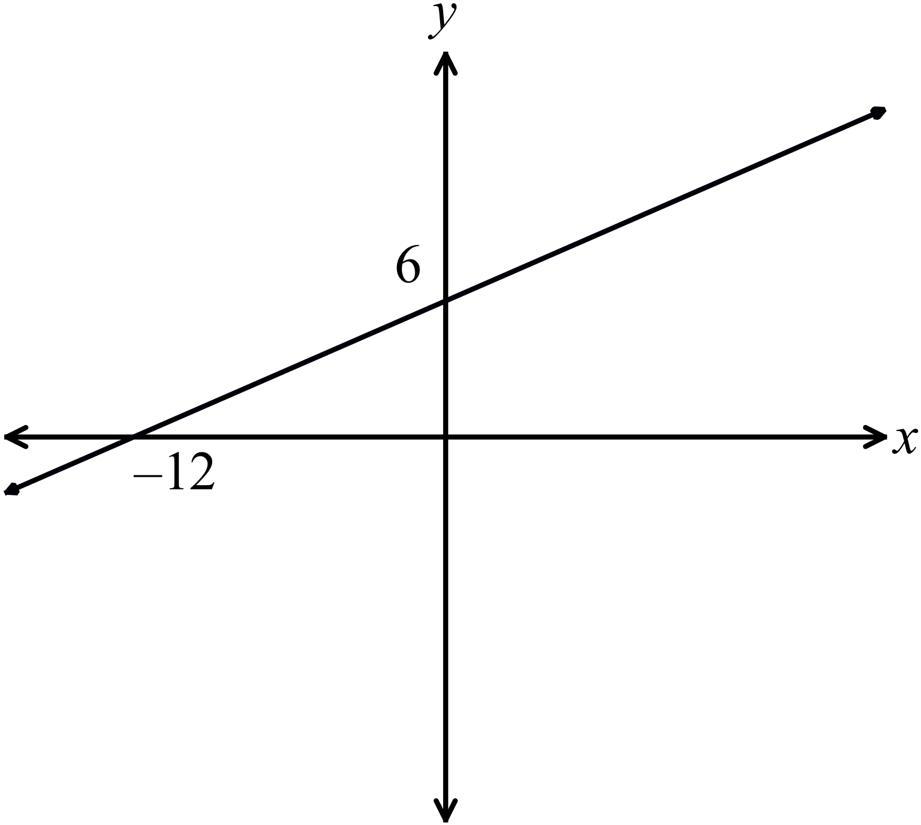(C) (D)
12 | What is the equation of the curve shown below?  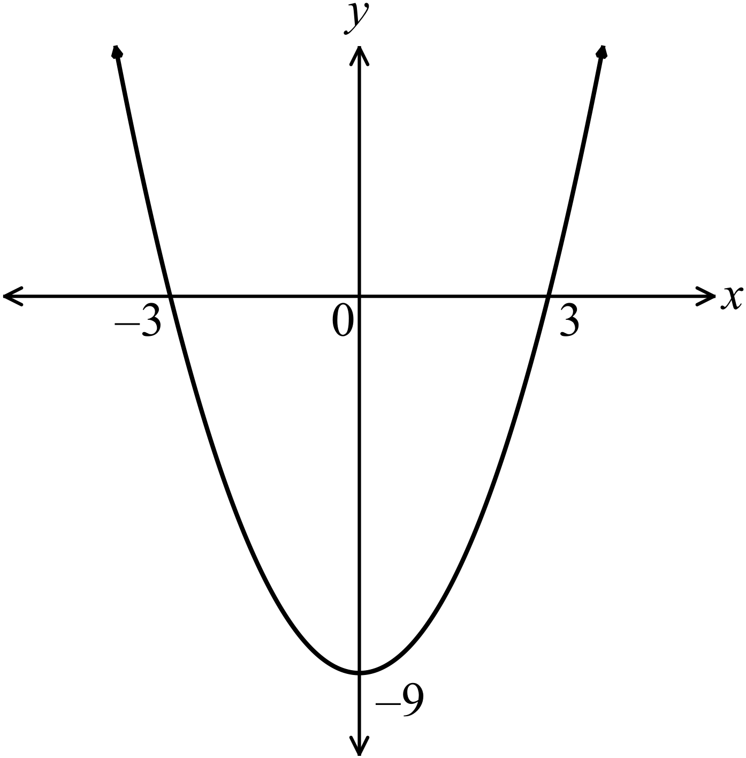  (A) 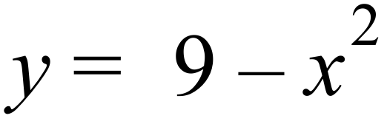 (B) 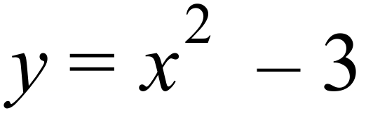 (C) 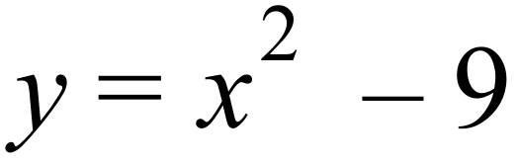 (D) 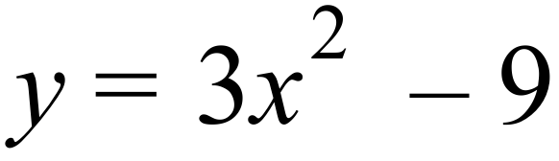
13 | 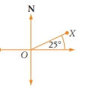  What is the bearing of X from O ?  (A) 25º (B) 65º (C) 025º (D) 065º
14 | Each interior angle of a regular octagon is  (A) 1080 (B) 80 (C) 135 (D) 125
15 | Karen and Barry are discussing having a family. They agree they would like to have three children. Karen says that she would like to have two girls and a boy in any order. What is the probability that she will get her wish if they do have three children?  (A) (B) (C) (D)
16 | Nathan has invested $5000 at 8% p.a. compounded yearly, for a holiday.  What is the total value of his investment after 3 years?  (A) $5100.67 (B) $6200.00 (C) $6298.56 (D) $6351.19
17 | P varies inversely with q. If when q = 4, P= 38, find P when q = 5  (A) 5.1 cm (B) 7.8 cm (C) 73.2 (D) 30.4 cm
18 | What is the value of sin 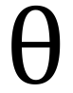?  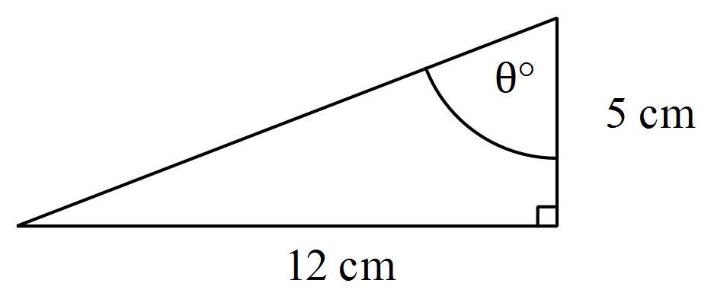  (A) 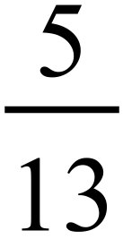 (B) 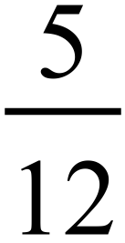 (C) 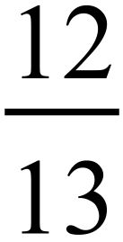 (D) 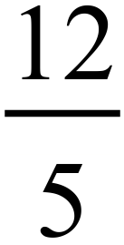

End of Multiple Choice Questions

Answer in the space provided

 | Linear Relationships (7 marks) | Mark
1 | Write the equation of a line that has a gradient of 2 and a y-intercept of −5. | [1]
2 | The interval AB on a number plane has endpoints A(−2, 10) and B(4, 5). Find:  a). the gradient of AB.  b). the length of AB as a surd.  c). the midpoint of AB. | [1]  [1]  [1]
3 | Find the gradient of the line 3x - 4y = 8. | [1]
4 | Find the equation of the line that is perpendicular to y = 2x + 6 passing through the point (2,-7) | [2]
Answer in the space provided

 | Compound Interest (7 marks) | Mark
1 | Calculate the simple interest when $7500 is borrowed at 5% p.a. for 5 months. | [1]
2 | A principal of $25 000 is invested at 4.5% p.a. compounded monthly for 3 years.  Calculate:  a). the final amount of the investment.  b). the interest earned. | [1]  [1]
3 | If Peter annual salary is $85000. He receives 17.5% for his leave loading of 4 weeks pay. Calculate his  a). Weekly pay ( Assume 1 year = 52.18 weeks)  b) His annual leave loading | [1]  [1]
4 | Braden bought a new car for $14990, which depreciates by 10% p.a.  - Find the depreciated value of the car after 5 years.  - Express the depreciated value as a percentage of the original price correct to 1 decimal point. | [1]  [1]
Answer in the space provided

 | Surface Area (7 marks) | Mark
1 | Find the total surface area of this closed semi cylinder.  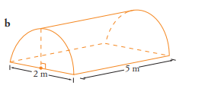 | [2]
2 | Find its surface area.  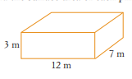 | [2]
3 | 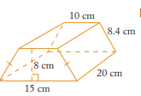  Finf the total surface area of the solid. | [3]

Answer in the space provided

 | Equations & Inequalities (7 marks) | Mark
1 | Solve b² - 5b = 0 | [2]
2 | a). Solve 5-2m > 7  b). Graph the solution on the number line below. | [2]  [1]
3 | A rectangle is four times as long as it is wide.  Find its length and width if its perimeter is 180 cm. | [2]

Answer in the space provided

 | Data Analysis (7 marks) | Mark
1 | 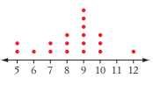  This following is a dot plot.  Find:  a). the range.  b). the mode.  c). the median.  d) the interquartile range | [1]  [1]  [1]  [1]
2 | 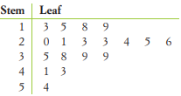  a). Describe the shape of this distribution.  b). Describe an outlier? | [1]  [1]
3 | 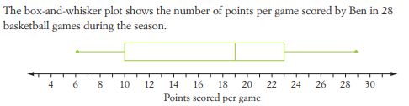  How many percent did Ben scored greater than to 23 points? | [1]

Answer in the space provided

 | Graphs (7 marks) | Mark
1 | If y = x² is drawn.  Describe the effect of the following graph in relation with the graph y = x²  Use words like moved up/down/left/right , wider/narrower , concave up/down , reflecting, coefficient of…etc  a) y = 3x²  b) y = x² + 1  c) y = (x+1)²  d) y = -x² | [1]  [1]  [1]  [1]
2 | a) x² + y² = 8 represents a circle.  What is the centre of the circle and the radius?  b) Write down one exponential equation which cuts the y axis at (0,2) | [2]  {1}
Answer in the space provided

 | Trigonometry (7 marks) | Mark
1 | 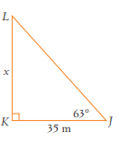  Find x correct to 1 decimal place | [2]
2 | 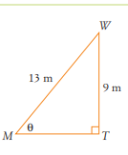  a).  Find angle WMT to the nearest minutes. | [2]
3 | 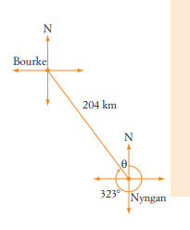  Colin leaves Nyngan and drives 204km to Bourke  The bearing of Bourke from Nyngan is 323º  a) Find the value of θ in the diagram.  b) How far north of Nyngan is Bourke ?  c) What is the bearing of Nyngan from Bourke? | [1]  [1]  [1]
Answer in the space provided

 | Algebra (7 marks) | Mark
1 | Expand and simplify (x+2)(x-3) | [1]
2 | Factorise each of these expressions.  a). x²y + xy²  b) x(x − 5) - 3(x − 5)  b). x² - x - 6 | [1]  [1]  [2]
3 | Expand and simplify 5(2a − 5 + b) − 7(b − 3a) | [2]
Answer in the space provided

 | Probability (7 marks) | Mark
1 | Two dice are rolled ,  a). Draw a table to list all outcomes.  b). How many outcomes are there?  c). Find the probability of rolling a double (both numbers the same).  d). Find the probability of rolling a total of 7. | [2]  [1]  [1]  [1]
2 | A bag contains 5 red marbles, 8 green marbles and 7 yellow marbles.  Two marbles are drawn from the bag without replacement.  What is the probability that:  a). given one marble is red, the other is yellow in that order?  b). given one marble is green, the other is also green? | [1]  [1]
Answer in the space provided

 | Geometry (7 marks) | Mark
1 | What is the angle sum of a polygon with 9 sides. | [1]
2 | How many sides does a regular polygon have if its exterior angle is 36º. | [1]
3 | 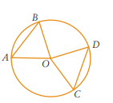  O is the centre of the circle and AB=CD.  Prove that ∆OAB≡∆COD | [3]
4 | 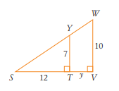  a) Which test shows that ∆STY ||| ∆SVW. (Hint : No abbreviation…write a statement)  b) Find the value of y. ( Leave answer in exact form) | [1]  [1]
Answer in the space provided

 | Simultaneous equation (7 marks) | Mark
1 | a) Use the method of substitution to solve  y= 5 – 2x and  y=3x + 2  b) Use the method of elimination to solve  5y – 4x = 1  2y – 3x = 6 | [2]  [2]
2 | a) Peter bought a total of 16 DVDs and CDs. Each DVD cost $25 and each CD cost $18. Altogether, Peter spent $351. How many CDs did he buy?  ( Form 2 equations and solve simultaneously) | [3]
End of Exam
Section I Multiple Choice Answer Sheet Name:________________

* Tick or Cross in only ONE box for each question. CLASS : __________

Questions | A | B | C | D
1
2
3
4
5
6
7
8
9
10
11
12
13
14
15
16
17
18

